Request for Information #19-2026

Multi-Purpose Support Vessels and ROV

Distributed on: November 3, 2026

Response Requested by: December 3, 2026

ExxonMobil Guyana Limited (EMGL)

- Objective

This Request for Information (RFI) seeks detailed technical information from suppliers for meeting EMGL's bid selection requirements for Provision and Operation of Multi-Purpose Support Vessels (MPSVs) in and around Georgetown, Guyana
This RFI has several objectives:

First, we may use responses from you and the other participants to validate and further develop our team’s recommendations for inclusion in the Request for Proposal (RFP) for Multi-Purpose Support Vessels (MPSVs) in and around Georgetown, Guyana. The RFI process allows us to seek your input and develop a list of qualified bidders before structured bid rules take effect. If a supplier is exploring potential partnership options for qualification to perform a scope of work, it is not mandatory that a formal legal partnership has been established. Any technically qualified business model may be considered for inclusion in the RFP process. If this applies to you, clearly describe and explain the potential partnership intent in your response.

Second, the RFI process provides you with an opportunity to begin developing your responses to some of the potential requirements if you are selected for the RFP.

Finally, EMGL in its sole discretion, may divide or reallocate the services described in this RFI and in a future RFP (Request for Proposal) into several enabling agreements that may be awarded to more than one bidder.

Please be aware that this RFI does not imply any commitment at this stage from EMGL to acquire goods or services from any supplier. All expenses or costs incurred by or for your firm as a result of your participation in the RFI and any subsequent RFP process shall be at your sole cost and expense. Your participation in the RFI process does not guarantee an invitation to participate in an RFP process. There may be no RFP or Agreement issued related to this RFI.

- Background

General
ExxonMobil Guyana Limited (EMGL) plans to put in place an enabling agreement(s) for the provision and operation of Multi-Purpose Support Vessels (MPSVs).

The scope of this Request for Information (RFI) is to identify suppliers who can provide Multi-Purpose Support Vessels (MPSVs) to EMGL and the Supplier will be expected to meet the below specifications as follows:

Multi-Purpose Support Vessel (MPSV) Specifications
MPSV to have the following features:
- Availability at the end of 2027 for 1-3 years or longer; (potential 2+ MPSVs).
- General operations to include (but not limited to) the following:
  - Open Water Lock Down Bushings (OWLDB) new for 2027
  - Tubing head installation/recovery & testing
  - Subsea tree installation/recovery & testing
  - SCIV cycling
  - Flying lead installation & flying lead mapping
  - Jumper installation
  - Well Commissioning
  - General life of field operations (pod swap, choke swap, etc.)
  - Various specialty scopes
  - Manifold
  - Suction piles
  - Mud mats
  - Flexible jumpers
- Designed for operation in severe weather conditions and high station keeping capability.
- Operating draft + Under Keel Clearance (UKC) – 6.5m or less
  - Vessel must be able to access GYSBI dock
  - Also requires navigation of the sandbar to access Demera River
- Minimum DP2 dynamic positioning system
- Active heave compensated crane
  - Vessels with cranes in the range of 150 MT – 400 MT
    - <150MT will not be considered
  - 3,000m crane wire length (2800m minimum usable)
  - Whip line on primary crane (2800m wire length minimum usable)
  - Ability to deploy rigid & TCP (Thermoplastic Composite Pipe) flexible jumpers from vessel’s own deck:
    - Jumper length: 36m
    - Max spreader bar length: 42m (36m minimum)
    - Jumper, spreader bar, & rigging max height: 29m
    - Jumper, spreader bar, & rigging max weight: 49mT in air (42mT in water)
  - Ability to deploy horizontal TCP jumper basket with flexible jumper (slide on following page)
    - Installation basket dimensions: 17.5m x 10m x 2.4m (height)
    - Empty basket weight: 42t
    - Basket weight with jumper: 55t
    - 4-part basket rigging height: ~16m
  - 20MT active heave-compensation (AHC) secondary subsea crane or AHC subsea winch capability (2800m wire length minimum)
    - Necessary for subsea installation of horizontal TCP jumper
- Deck size min 1,000 m2 (1,200m2+ preferred)
  - Adequate space to safely deploy and recover horizontal TCP jumper
  - Meets requirements for Reel Drive System (RDS) for steel flying lead deployment
    - Dimensions: L 6.6m x W 2.44m x H 4m
    - Weight: 30,000 lb (13608 kg)
    - Power requirements:
      - 480V 3Phase (main electrical motor), 120V (motor heater)
- Ultra-Short Baseline (USBL) survey system: outfitted with fiber optic connection to Remotely Operated Vehicle (ROV) cabin & survey office
- 2x 200 hp work class ROVs
  - 3000m depth rated
  - Active Heave Compensated ROV winches
  - HD Cameras
  - Subsea Pressure Test kit (5k and 10k pumps, hoses, isolation panel, 17H dual port hot stabs, digital or analog gauges (5k – 12.5k)
  - API 53 Compliant BOP Closure Capability (integrated or skid)
- 360 degree Closed-Circuit Television (CCTV) System; 90 day footage storing capability
- Potable water maker, minimum 25 m³ capability
- ExxonMobil Approved Electronic Fuel Management System installed
- Internet
  - Starlink® 5TB or equivalent + VSAT (Very-Small-Aperture Terminal) (4/4 MB/s) package
- Support capabilities
  - Health, Safety and Environment (HSE) management structure
  - Project management
  - Project engineering
    - Lift plans and analysis
    - Sea-fastening and deck plan analysis
    - HAZID
- Preferred features:
  - Dedicated ROV control room
  - Helideck (S92 rated)
  - Moonpool for ROV deployment or other high sea state tolerant method
  - Constant tension deck tuggers and crane tuggers (120m or longer)
  - Steel Flying Lead (SFL) deployment chute
  - Vessels built in 2016 or newer (2010 or newer will be considered)
  - Provide full suite of tooling including gyros, positioning compatts, DP beacons, and LBL kit (for As-built Surveys & Jumper Metrology).
  - Bid structure options:
    - Vessel, ROV, and survey covered in a single contract
    - Vessel, ROV, and survey in separate Contracts
  - LTE antenna optional addition
  - Fuel hose for in-field bunkering contingency
    - Primary bunkering at GYSBI dock 6.5m draft
- Engineering and execution Capability
  - Demonstrated capability and relevant experience in the engineering, planning and offshore installation of subsea jumpers, flying leads, subsea structures and other associated subsea hardware in comparable water depths and operating environments.
  - Describe in-house engineering resources and capabilities to support installation methodology development, lift and rigging studies, seafastening design, transportation and installation analysis, contingency planning, fabrication, procurement, loadout & mobilization support and offshore execution support.
  - Optional: Demonstrated capability to provide an integrated EPCI execution approach, including engineering, procurement of installation aids, offshore construction management and execution support through project completion.
- Optional packages:
- Remote ROV piloting
- Geospatially accurate digital twin photogrammetry

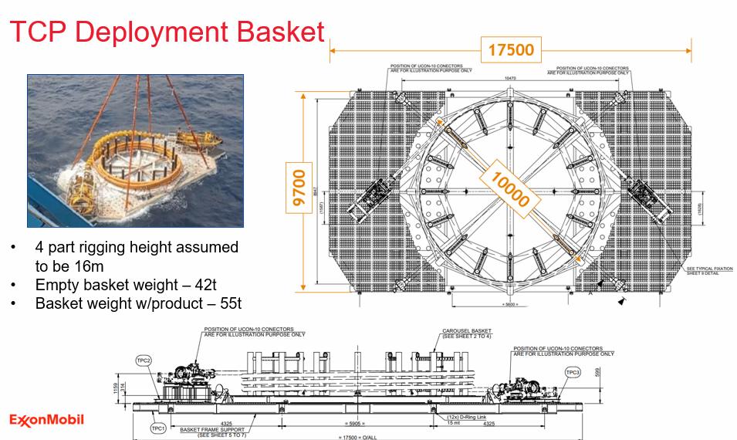

- Local Content Requirements
3.1 EMGL’s local content strategy is important to our business. Its elements are integrated into our daily processes and procedures and guide the way we work today and plan for tomorrow.

3.2 Using a multi-tiered approach, EMGL focuses on building workforce and supplier capabilities in conjunction with strategic investments in the local community.

3.3 During the bid process, all prospective EMGL contractors are required to demonstrate awareness of the Local Content Act (2021) and its potential application to their work under the scope.

3.4 Bidders may be expected to include in their submission a preliminary local content strategy outlining how they will deliver on the local content expectations outlined below and those captured in the Act, and, upon award, implement an acceptable plan. Should the successful bidder be required to submit local content plans to the Government of Guyana under the Local Content Act (2021) they will also provide a copy of those plans to EMGL.

3.4 The following requirements apply to orders that will be performed, or with exercise of contractor’s best efforts could be performed, wholly or in any part in Guyana (including without limitation the Guyana Exclusive Economic Zone) or with utilization of any Guyanese subcontractor, vendor, or similar Guyanese content.

3.5 The below requirements specific to EMGL contractors are in addition to the Local Content Act (2021) issued by the Government of the Cooperative Republic of Guyana; in the event of a conflict between these requirements and those of the Government of Guyana explicit instruction must be sought by EMGL.

REQUIRED ACTIVITIES:

A. Contractor Procurement Activities:

To support EMGL’s objectives of giving preference to qualified local suppliers from Guyana, a contractor shall:

        - Give fair and adequate opportunity and first consideration to the following:
- The purchase of Guyanese goods and services provided such goods and services are available on a timely basis of the quality and in the quantity required by the contractor at competitive prices.
- Utilization of Guyanese contractors insofar as they are commercially competitive and satisfy the contractor's financial and technical requirements and meet the requirements of this section.
        - Establish appropriate tender procedures for the acquisition of goods, materials, and services, which shall ensure that Guyanese contractors are given fair and adequate opportunity to compete for the supply of goods and services.
        - Establish procedures to provide the contractor’s Guyanese subcontractors feedback following contracting activities.
        - Ensure that the contractor’s subcontractors comply with the requirements contained in this section.
        - Steward the contractor’s, and its sub-contractors’, service performance, including local content development progress in accordance with these requirements and the contractor's local content plan.

B. Contractor’s Employment Opportunities

To support EMGL’s objectives of giving preference to qualified local personnel and suppliers from Guyana, a contractor shall:
        - Prepare and implement a program to give fair and adequate opportunity and first consideration for employment of Guyanese nationals having appropriate qualifications and necessary experience to perform job responsibilities commensurate with the contractor’s scope of work.
        - Ensure that the contractor’s subcontractors comply with the requirements contained in this Section.
        - Steward the contractor’s and its sub-contractors’ local content development progress in accordance with this guidance and the contractor's local content plan.

C. Contractor’s Use of External Resources:

1. Centre for Local Business Development
- To facilitate transparent local hiring and contracting, a contractor is encouraged to consider using the following capabilities provided by the Centre for Local Business Development (CLBD):
          - Advertising upcoming vacancies and tenders with potential local content.
          - Publishing Vacancies/Expression of Interest/Tenders in the public domain for approximately two weeks to one month (as relevant) via the Centre for Local Business Development Hub and CLBD Facebook/Website.
          - Utilize the Hub as a resource market, for sector insights and for market intelligence related to Guyanese contractors that meet requirements.
          - Plan communications for announcements of tender award/hiring/training as appropriate.
          - Provide opportunities for feedback following Expression of Interests/Request for Information (RFI) and bids to Guyanese vendors.

- A contractor should also consider engaging, and actively collaborating with the Centre for Local Business Development.
(i) The Centre’s role is to facilitate communication between suppliers, contractors and subcontractors, with a goal to build the capacity of Guyanese small and medium enterprises. The Centre will maintain a Supplier Registration Portal and is able to provide a mechanism for advertising opportunities for Guyanese goods and services, for a contractor’s use.
(ii) EMGL does not endorse or recommend any supplier listed on the Centre Hub. As such, a contractor should perform appropriate due diligence on any supplier prior to use. The Centre is located in Georgetown at 253-254 South Road, Bourda on the top floor of the IPED Building. The website is: www.centreguyana.com

2. Online & Social Media – Publishing Vacancies/Expression of Interest/Request for Information in the public domain for approximately two weeks to one month, as relevant, via relevant online and social media sites (EMGL, Local Content Secretariat, contractor, and newspapers).

D. Contractor’s Local Content Metrics Reporting (If Required)
      - A contractor shall provide local content reporting metrics using an EMGL-provided format or digital tool.
      - Metric reporting requests will be sent at least twice annually to the contractor. EMGL reserves the right to change the frequency of metric requests to the contractor.
      - Should the contractor be required to submit metrics to the Government of Guyana under the Local Content Act (2021), EMGL may request a copy of those reports.

- Safety, Security, Health & Environment (SSHE)

ExxonMobil Guyana Ltd and its partners are committed to providing a safe, healthy, and environmentally sound workplace for employees, contractors and subcontractors. Interested Suppliers must have a comprehensive Health, Safety, Environmental and Quality management system that meets, at a minimum, all requirements of ExxonMobil, and local regulatory processes.

- RFI Submission Instructions

Please complete Section 8 - Questionnaire, elaborating on each item as appropriate and keeping the following in mind:

- Please answer the questions as completely as possible and advise if you cannot answer a particular question.

- Please note the word limit for each section. Submitters should not exceed the word limit.

- Please submit your response in electronic form using any of the following electronic formats: Microsoft Word, Microsoft Excel, Adobe PDF, etc.

- Please do not include any links to documents or sites in your responses as proof points for qualifications. EMGL cannot access external links.

- Your e-mailed responses should be limited to a reasonable size (<5MB). If the response is >5MB, then multi-part email submissions <5MB are acceptable.

- Please do not submit pricing or price proposal information at this stage.

- Your submittal should not include information which you consider proprietary, trade secrets or confidential.

- Please submit all questions to email address: EM.Guyana.Procurement@exxonmobil.com

- A clarification session will be held for this RFI. Please use this link to sign up ExxonMobil Clarification Session For Multi-Purpose Support Vessels and ROV.
Date and time of the clarification will be shared upon registration.

- Key Dates in the RFI Process

November 3, 2026 RFI to be issued

November 19, 2026 Clarification Session

December 3, 2026 Deadline for supplier to submit completed RFI (firm)

Q1 2027 Evaluation of RFI responses (estimated)

Q2 2027 RFP invitations (estimated)
- Submission of RFI with all complete documents

All documents required to be submitted are due no later than 5:00 PM, December 3, 2026.

Contact for questions: EM.Guyana.Procurement@exxonmobil.com

How to Submit:

1. Complete Required Documents and include in an email

- Completed Questionnaire (Section 8 attached excel)
- MPSV Fleet Availability (attached excel)
- Completed Prospective Business Associates Questionnaire (PBAQ)
- Copy of the company’s Articles of Incorporation (including the page with the Directors/Management and details of nationality)
- Copy of the company’s Certificate of Registration (company TIN) from the Guyana Revenue Authority (or equivalent if international)
- Copy of company’s organizational chart with details on nationality of all personnel

2. Send Email with the following title format:

Supplier Name – RFI 19-2026 MPSV and ROV – Final RFI Submission

3. Send email to: EM.Guyana.Procurement@exxonmobil.com

4. Kindly note it’s recommended but not a requirement to register at the CLBD in order to respond to any of our RFI’s as this request is open to all interested companies.

