Request for Information #18-2022

Onshore Pipeline Construction

Distributed on: June 23, 2022

Response Requested by: July 15, 2022

Esso Exploration and Production Guyana Limited (EEPGL)

1. Objective

This Request for Information (RFI) seeks detailed commercial and technical information from suppliers for meeting Esso Exploration and Production Guyana Limited’s (EEPGL) bid selection requirements for the construction of an onshore pipeline in Guyana.

This RFI has the following key objectives:

- Identify companies who can construct an onshore pipeline at the required location per EEGPL’s minimum requirements.

- EEPGL is expected to use potential Company’s responses to validate and further develop EEPGL recommendations for inclusion in the Request for Proposal (RFP), therefore the RFI process provides for EEPGL to seek input and develop a list of qualified Companies (bidders).

- The RFI process provides the potential Companies an opportunity to begin developing responses to potential requirements in the event the Company is selected for the RFP.

First, we may use responses from you and the other participants to validate and further develop our team’s recommendations for inclusion in the Request for Proposal (RFP). The RFI process allows us to seek your input and develop a list of qualified bidders before structured bid rules take effect.

Please be aware that this RFI does not imply any commitment at this stage from EEPGL to acquire goods or services from any supplier. All expenses or costs incurred by or for your firm as a result of your participation in the RFI and any subsequent RFP process shall be at your sole cost and expense. Your participation in the RFI process does not guarantee an invitation to participate in an RFP process.

2. Background

General

EEPGL plans to award a Lump Sum (LS) contract to construct an onshore gas pipeline and associated facilities in the Georgetown, Guyana area (West side of the Demerara River). Figure 1 provides an overview of the proposed onshore pipeline route.

Figure 1: Onshore Pipeline Route Overview
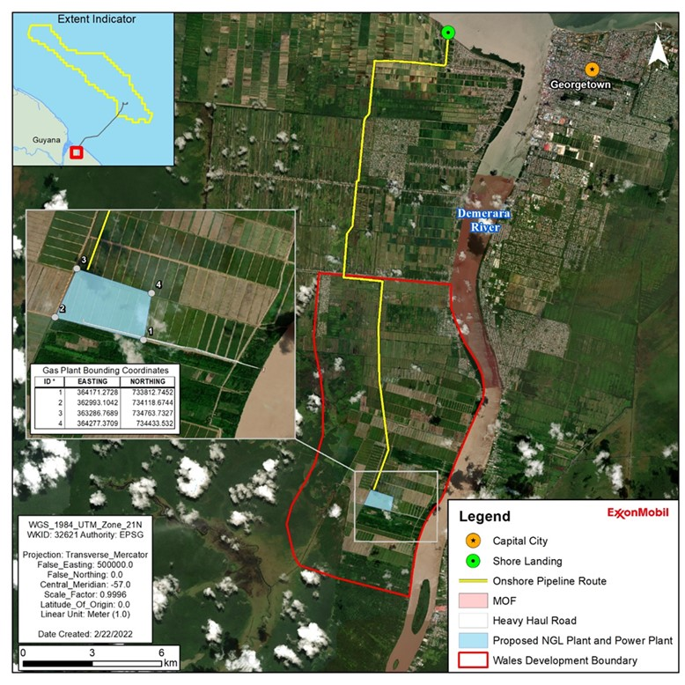

The scope of this Request for Information (RFI) is to identify contractors capable of procuring materials and constructing an onshore gas pipeline with the parameters described below:

- Description of facilities to be constructed:

    - 12” welded, carbon steel gas pipeline; approximately 25km long
    - Pipeline to be installed below ground; 1.22m minimum cover to top of pipe
    - Pipeline will include:
      - Clearing, grading, and maintaining right-of-way (ROW) to facilitate installation and safe movement of equipment and vehicles.
      - Creation of ROW access via track/road improvement (as/if required).
      - Transportation and handling of line pipe within Guyana and work site.
      - Cold bending pipe sections to align with curvatures of existing terrain.
      - Welding and field joint coating following approved specifications.
      - Non-destructive testing (e.g., x-ray of welds) and overall quality control.
      - Trenching (including trench dewatering), lowering-in, backfilling, and installation of required environmental control devices to limit erosion.
      - Installation of cathodic protection
      - Numerous canal and road crossings (HDDs will be required). It is anticipated that ~10 HDDs will be required.
      - A minimum of one above ground valve station, with installation of appropriate fencing, lighting and security as needed.
      - An above ground receiving facility including civil work, fencing, valves, gas custody metering skid, lighting, electrical, instrumentation, etc.

- Perform as-built survey(s) and produce red-lined alignment sheets

- Procure locally and globally sourced equipment and materials (reviewed and inspected to meet EEPGL specifications) to construct the onshore gas pipeline and associated facilities.

- Resources / materials provided by EEPGL:

    - Line pipe and induction bends (coated)
    - Valves
    - Cathodic protection materials
    - Right of Way (ROW) land access
    - Gas custody metering skid

EEPGL is also interested in the contractors’ capabilities to perform and support any field engineering requirements for the installation of the onshore gas pipeline and associated facilities. Engineering services is not the primary intent of this RFI, and is currently not anticipated to be in the base case for the construction contractor to perform.

3. Local Content Requirements

3.1 EEPGL’s local content strategy is important to our business. Its elements are integrated into our daily processes and procedures, and guide the way we work today and plan for tomorrow.

3.2 Using a multi-tiered approach, EEPGL focuses on building workforce and supplier capabilities in conjunction with strategic investments in the local community.

3.3 During the bid process, all prospective EEPGL contractors are required to demonstrate awareness of the Local Content Act (2021) and its potential application to their work under the scope.

3.4 Bidders are expected to include in their submission a preliminary local content strategy outlining how they will deliver on the local content expectations outlined below and those captured in the Act, and, upon award, implement an acceptable plan. Should the successful bidder be required to submit local content plans to the Government of Guyana under the Local Content Act (2021) they will also provide a copy of those plans to EEPGL.

3.5 The following requirements apply to orders that will be performed, or with exercise of contractor’s best efforts could be performed, wholly or in any part in Guyana (including without limitation the Guyana Exclusive Economic Zone) or with utilization of any Guyanese subcontractor, vendor, or similar Guyanese content.

3.6 The below requirements specific to EEGPL contractors are in addition to the Local Content Act (2021) issued by the Government of the Cooperative Republic of Guyana; in the event of a conflict between these requirements and those of the Government of Guyana explicit instruction must be sought by EEPGL.

Required Activities:

A. Contractor Procurement Activities:

To support EEPGL’s objectives of giving preference to qualified local suppliers from Guyana, a contractor shall:

        - Give fair and adequate opportunity and first consideration to the following:
          - The purchase of Guyanese goods and materials, provided such goods and materials are available on a timely basis of the quality and in the quantity required by the contractor at competitive prices.
          - Utilization of Guyanese contractors insofar as they are commercially competitive and satisfy the contractor's financial and technical requirements and meet the requirements of this section.
        - Establish appropriate tender procedures for the acquisition of goods, materials, and services, which shall ensure that Guyanese contractors are given fair and adequate opportunity to compete for the supply of goods and services.
        - Establish procedures to provide the contractor’s Guyanese subcontractors feedback following contracting activities.
        - Ensure that the contractor’s subcontractors comply with the requirements contained in this section.
        - Steward the contractor’s, and its sub-contractors’, local content development progress in accordance with these requirements and the contractor's local content plan.

B. Contractor’s Employment Opportunities

To support EEPGL’s objectives of giving preference to qualified local personnel and suppliers from Guyana, a contractor shall:
        - Prepare and implement a program to give fair and adequate opportunity and first consideration for employment of Guyanese nationals having appropriate qualifications and necessary experience to perform job responsibilities commensurate with the contractor’s scope of work.
        - Ensure that the contractor’s subcontractors comply with the requirements contained in this Section.
        - Steward the contractor’s and its sub-contractors’ local content development progress in accordance with this guidance and the contractor's local content plan.

C. Contractor’s Use of External Resources:

1. Centre for Local Business Development

a. To facilitate transparent local hiring and contracting, a contractor shall consider using the following capabilities provided by the Centre for Local Business Development (CLBD):
          - Advertising upcoming vacancies and tenders with potential local content.
          - Publishing Vacancies/Expression of Interest/Tenders in the public domain for approximately two weeks via the Centre for Local Business Development Supplier Registration Portal (SRP) and CLBD Facebook/Website.
          - Utilize SRP to augment any bid lists with Guyanese contractors that meet requirements.
          - Plan communications for announcements of tender award/hiring/training as appropriate.
          - Provide opportunities for feedback following Expression of Interests/Request for Information (RFI) and bids to Guyanese vendors.

- A contractor should engage, and actively collaborate with, the Centre for Local Business Development.
(i) The Centre’s role is to facilitate communication between suppliers, contractors and subcontractors, with a goal to build the capacity of Guyanese small and medium enterprises. The Centre will maintain a Supplier Registration Portal and is able to provide lists of various Guyanese goods and services, for a contractor’s use.
(ii) EEPGL does not endorse or recommend any supplier listed on the Portal. As such, a contractor should perform appropriate due diligence on any supplier prior to use. The Centre is located in Georgetown at 253-254 South Road, Bourda on the top floor of the IPED Building. The website is: www.centreguyana.com

2. Online & Social Media – Publishing Vacancies/Expression of Interest/Tenders in the public domain for approximately two weeks via relevant online and social media sites (EEPGL, contractor, and newspapers).

D. Contractor’s Local Content Metrics Reporting
      - A contractor shall provide local content reporting metrics using an EEPGL-provided template. The template may be updated by EEPGL at any time.
      - Metric reporting requests will be sent at least twice annually to the contractor. EEPGL reserves the right to change the frequency of metric requests to the contractor.
      - Should the contractor be required to submit metrics to the Government of Guyana under the Local Content Act (2021) they will provide a copy of those reports to EEPGL.

4. RFI Instructions

Please complete Section 7 – Questionnaire excel file, elaborating on each item as appropriate and keeping the following in mind:

- Please use the attached spreadsheet for your response.
- Questionnaire should be completed in its entirety and submitted back in excel format with your company name in the file name.
- To avoid duplication of answers, you may reference other applicable sections of the questionnaire if the answer is already covered elsewhere.
- Please note the word limit for each section of the questionnaire. Submitters should not exceed the word limit.
- Additional attachments are permitted, but please only send if absolutely necessary. If you do send separate attachments to address any part of the questionnaire, please ensure the name of your file corresponds to the applicable section of the questionnaire.
- Please submit your response in electronic form using any of the following electronic formats: Microsoft Word, Microsoft Excel, Adobe PDF, etc.
- Your e-mailed responses should be limited to a reasonable size (<5MB). If the response is >5MB, then multiple submissions <5MB are acceptable.
- Please do not submit pricing or price proposal information at this stage.
- Your submittal should not include information which you consider proprietary, trade secrets or confidential.
- There will be no clarification meetings for this RFI. Please submit all questions to email address: EM.Guyana.Procurement@exxonmobil.com

5. Due Date Schedule & Key Dates in the RFI / RFP Process

June 23, 2022 RFI to be issued through the Center for Local Business
Development

July 15, 2022 Deadline for contractor to submit completed RFI

July/August 2022 Evaluation of RFI responses

August/September 2022 Potential Commencement of RFP invitations

January 2023 Potential Contract Award

6. Submission of RFI with all complete documents

All documents required to be submitted are due no later than 5:00 PM, July 15, 2022. No extensions will be granted.

Contact for Questions please email: EM.Guyana.Procurement@exxonmobil.com

How to Submit:

1. Complete Required Documents and include in an email:
- Completed Questionnaire (Separate Excel Spreadsheet)
- Completed PBAQ
  - This document does not need to be submitted by deadline.
  - Following receipt of RFI responses, EEPGL will engage with those companies separately on completion deadlines of this document.
- Copy of the company’s Articles of Incorporation (including the page with the Directors/Management and details of nationality)
- Copy of the company’s Certificate of Registration (company TIN) from the Guyana Revenue Authority
- Copy of company’s organizational chart with details on nationality of all personnel’s.

2. Send Email with the below title format:

Your Company Name – RFI #18-2022 Onshore Pipeline Construction – Final RFI Submission

3. Send email to: EM.Guyana.Procurement@exxonmobil.com

4. Kindly note it’s not a requirement to register at the CLBD in order to respond to any of our RFI’s as this request is open to all interested companies.

7. Questionnaire – See Separate Excel Spreadsheet

