**Request for Information #04-22**

**Offshore Terminal Dynamically Positioned Offloading Tug (DPOT)**

Distributed on: **May 12, 2022**

Response Requested by: **June 15, 2022**

**Esso Exploration & Production Guyana Limited (EEPGL)**

**1. Objective**

This Request for Information (RFI) seeks detailed technical information from qualified shipowners (Owners) for meeting EEPGL's bid selection requirements to supply one (1) or more offshore terminal **Dynamically Positioned Offloading Tugs (DPOTs or Vessels)** for a firm charter period in support of the EEPGL’s offshore oil production program from multiple floating production, storage and offloading units (FPSOs) located in the Stabroek license area approximately 120 nautical miles northeast of Georgetown, Guyana.

This RFI has several objectives:

First, we may use responses and information from all respondents to validate and further develop recommendations for inclusion in the Request for Proposal (RFP) to supply one (1) or more **DPOTs** for use at EEPGL’s offshore terminal in the Stabroek license area. The RFI process facilitates potential bidder input as well as development of a list of potential qualified bidders before structured bid rules take effect.

Second, the RFI process provides potential bidders an opportunity to begin developing their responses to some of the potential requirements if selected for the RFP.

Finally, EEPGL in its sole discretion, may divide the services described in this RFI and in a future RFP (Request for Proposal) into several enabling agreements that may be awarded to more than one bidder.

***Please be aware that this RFI does not imply any commitment at this stage from EEPGL or any of its affiliates to acquire goods or services from any supplier. All expenses or costs incurred by or on behalf of any respondent as a result of participation in the RFI and any subsequent RFP process shall be at respondents sole cost and expense. Participation in the RFI process does not guarantee an invitation to participate in an RFP process.***

**2. Background**

**General**

EEPGL plans to put in place an enabling (non-commitment) agreement for provision of one (1) or more DPOTs dedicated to service between the EEPGL shore base in Georgetown, Guyana (on the Demerara River) and the area of operations in the Stabroek license area in offshore Guyana approximately 120 nm NE of Georgetown in 1,750m water depth.

The scope of this RFI is to identify qualified Owners who can supply one (1) or more DPOTs that meets EEPGL standards to as follows:

1. **Charter Particulars**
2. Charter Type: Time charter
3. Charter Duration: Firm charter period for each Vessel; each Charter shall include Charterer's options to extend the charter duration.
4. Delivery Area: Georgetown, Guyana
5. Commencement: Charterer’s desired Charter commencement dates are as follows:

Vessel 1: TBD

Vessel 2 (Option): TBD

Vessel 3 (Option): TBD

Owners are invited to propose their own charter commencement dates to reflect e.g. shipyard production schedules if newbuild vessels are to be offered.

1. Trading Range: Guyana coastal waters and exclusive economic zone (EEZ), as well as surrounding areas of the Western Atlantic and other navigable ports as Charterer may designate. Company reserves the right to change charter area when exercising options and/or extensions.
2. Compliance: Vessels and Owner must be, and remain, in full compliance with all applicable international conventions, laws, regulations, and/or other requirements of the country of the Vessels’ registry, and of the countries, ports and/or places to which the Vessel may be ordered while in Charterer’s service. For purposes of this solicitation, it may be assumed that there are no limitations (except those sanctioned by US Government) regarding the country of the Vessels’ registry.
3. Charter Party Form: EEPGL form, all terms to be agreed. The contract will consist of an enabling-type EEPGL Master Time Charter Agreement, with individual Vessel Orders for each Vessel.
4. **Scope of Services**

DPOTs will enable year round availability for offloading from floating production, storage and offloading units (FPSO) to Very Large Crude Carrier (VLCC) including during onsetting metocean conditions. Typical modes of operation to be considered in the DPOT design will be:

* Transfer personnel to/from FPSO and ET (export tanker) via articulating/telescoping or heave compensated gangway.
* Tow a tandem moored VLCC and holdback tug
* Connect to FPSO offloading hose and discharge to ET via DPOT offloading equipment; DPOT to include offloading hose reel, hose, winch, hawser, quick release hook, hawser tension monitoring and other equipment to safely connect/transfer cargo to export tanker.
* DPOT offloading system shall include 3 x 50% booster pumps to enable discharge to ET.
* Maintain position and/or move between FPSO offloading sectors while transferring cargo to a tandem moored VLCC and holdback tug using dynamic positioning capability
* Loiter in operations area during time periods between tanker exports
* Moor at shore base (not on shore power, however vessel shall be fitted with shore power connection/breaker)
* Transit to/from shore base and operations area (at economical or maximum speed)
* Personnel transport and transfer to/from shore

Additional modes of operation to be considered in DPOT design:

* Perform hose maintenance (both for FPSO and DPOT offloading hose)
* Deploying, trailing, and retrieving OSR containment booms
* Fire fighting
* Field standby and rescue
* Helideck to receive helicopter flights (if feasible)
* Ability to conduct ROV operations (if feasible)

EEPGL is currently using tandem offloading and is looking to explore alternative options. Diagrams are pictured below for reference.

Current Tandem Offloading:

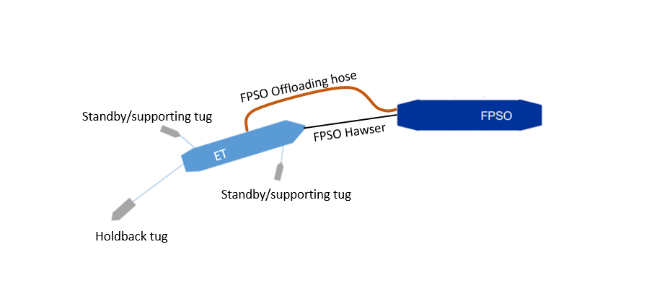

Alternative Option of DPOT Offloading:

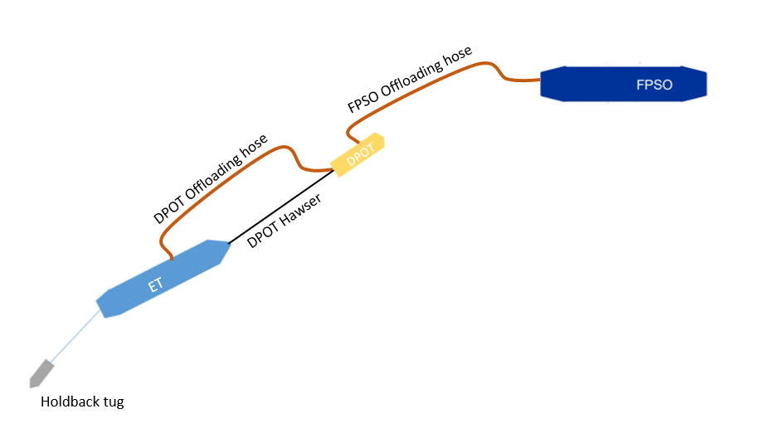

1. **Minimum Owner Qualifications**

Only those Owners deemed qualified by EEPGL will be considered to competitively tender for the work described herein. All nominated Vessel operators (i.e. that entity possessing an ISM Document of Compliance that will be the technical operator of the Vessels; hereinafter “Operator”) of those Owners selected to tender will be required to undergo an assessment of their safety and quality management systems using the Oil Companies International Marine Forum “Offshore Vessel Management Self-Assessment” (OVMSA) protocol; the EEPGL’s bid evaluation team will conduct a verification of each candidate Operator’s OVMSA assessment as part of the bid evaluation process and the winning Owner’s Operator shall be required to commit to a program of continuous improvement that is subject to verification by EEPGL throughout the life of the contract.

The Owner and Operator’s key personnel *must* have:

1. Demonstrated commitment to safety, health, environmental and security principles as reflected in the Operator’s safety and quality management systems;
2. Recent, relevant experience operating offshore terminal tugs in services similar to those described herein or the demonstrated ability to develop an adequately sized pool of qualified personnel prior to commencement of the Charter period; and
3. Recent, relevant experience managing a vessel newbuilding project (if Owner contemplates newbuild vessels for this work).

In addition to the above, the most highly-qualified Owner would *likely* have:

1. The ability to maximize business and employment opportunities for the citizens of Guyana as a result of and in relation to the work described herein;
2. Prior relevant experience on offshore oil and gas projects in the Caribbean or Western Atlantic basin; and
3. Prior relevant experience with ExxonMobil affiliated companies or other major oil and gas operators.

**3. Local Content Requirements**

3.1 EEPGL’s local content strategy is important to our business. Its elements are integrated into our daily processes and procedures, and guide the way we work today and plan for tomorrow.

3.2 Using a multi-tiered approach, EEPGL focuses on building workforce and supplier capabilities in conjunction with strategic investments in the local community.

3.3 During the bid process, all prospective EEPGL contractors are required to demonstrate awareness of the Local Content Act (2021) and its potential application to their work under the scope.

3.4 Bidders are expected to include in their submission a preliminary local content strategy outlining how they will deliver on the local content expectations outlined below and those captured in the Act, and, upon award, implement an acceptable plan. Should the successful bidder be required to submit local content plans to the Government of Guyana under the Local Content Act (2021) they will also provide a copy of those plans to EEPGL.

3.4 The following requirements apply to orders that will be performed, or with exercise of contractor’s best efforts could be performed, wholly or in any part in Guyana (including without limitation the Guyana Exclusive Economic Zone) or with utilization of any Guyanese subcontractor, vendor, or similar Guyanese content.

3.5 The below requirements specific to EEGPL contractors are in addition to the Local Content Act (2021) issued by the Government of the Cooperative Republic of Guyana; in the event of a conflict between these requirements and those of the Government of Guyana explicit instruction must be sought by EEPGL.

**REQUIRED ACTIVITIES**:

A. Contractor Procurement Activities:

To support EEPGL’s objectives of giving preference to qualified local suppliers from Guyana, a contractor shall:

* + - * 1. Give fair and adequate opportunity and first consideration to the following:

The purchase of Guyanese goods and materials, provided such goods and materials are available on a timely basis of the quality and in the quantity required by the contractor at competitive prices.

Utilization of Guyanese contractors insofar as they are commercially competitive and satisfy the contractor's financial and technical requirements and meet the requirements of this section.

* + - * 1. Establish appropriate tender procedures for the acquisition of goods, materials, and services, which shall ensure that Guyanese contractors are given fair and adequate opportunity to compete for the supply of goods and services.
        2. Establish procedures to provide the contractor’s Guyanese subcontractors feedback following contracting activities.
        3. Ensure that the contractor’s subcontractors comply with the requirements contained in this section.
        4. Steward the contractor’s, and its sub-contractors’, local content development progress in accordance with these requirements and the contractor's local content plan.

B. Contractor’s Employment Opportunities

To support EEPGL’s objectives of giving preference to qualified local personnel and suppliers from Guyana, a contractor shall:

* + - * 1. Prepare and implement a program to give fair and adequate opportunity and first consideration for employment of Guyanese nationals having appropriate qualifications and necessary experience to perform job responsibilities commensurate with the contractor’s scope of work.
        2. Ensure that the contractor’s subcontractors comply with the requirements contained in this Section.
        3. Steward the contractor’s and its sub-contractors’ local content development progress in accordance with this guidance and the contractor's local content plan.

C. Contractor’s Use of External Resources:

1. Centre for Local Business Development

a. To facilitate transparent local hiring and contracting, a contractor is encouraged to consider using the following capabilities provided by the Centre for Local Business Development (CLBD):

Advertising upcoming vacancies and tenders with potential local content.

Publishing Vacancies/Expression of Interest/Tenders in the public domain for approximately two weeks via the Centre for Local Business Development Supplier Registration Portal (SRP) and CLBD Facebook/Website.

Utilize SRP to augment any bid lists with Guyanese contractors that meet requirements.

Plan communications for announcements of tender award/hiring/training as appropriate.

Provide opportunities for feedback following Expression of Interests/Request for Information (RFI) and bids to Guyanese vendors.

1. A contractor should also consider engaging, and actively collaborating with, the Centre for Local Business Development.

(i) The Centre’s role is to facilitate communication between suppliers, contractors and subcontractors, with a goal to build the capacity of Guyanese small and medium enterprises. The Centre will maintain a Supplier Registration Portal and is able to provide a mechanism for advertising opportunities for Guyanese goods and services, for a contractor’s use.

(ii) EEPGL does not endorse or recommend any supplier listed on the Portal. As such, a contractor should perform appropriate due diligence on any supplier prior to use. The Centre is located in Georgetown at 253-254 South Road, Bourda on the top floor of the IPED Building. The website is: [www.centreguyana.com](http://www.centreguyana.com)

2. Online & Social Media – Publishing Vacancies/Expression of Interest/Tenders in the public domain for approximately two weeks via relevant online and social media sites (EEPGL, Local Content Secretariat, contractor, and newspapers).

D. Contractor’s Local Content Metrics Reporting

* + - 1. A contractor shall provide local content reporting metrics using an EEPGL-provided template. The template may be updated by EEPGL at any time.
      2. Metric reporting requests will be sent at least twice annually to the contractor. EEPGL reserves the right to change the frequency of metric requests to the contractor.
      3. Should the contractor be required to submit metrics to the Government of Guyana under the Local Content Act (2021) they will provide a copy of those reports to EEPGL.

**4. RFI Instructions**

Please complete Section 7 - Questionnaire, elaborating on each item as appropriate and keeping the following in mind:

* Please use the attached spreadsheet for your response using the drop down options.
* Please answer the questions as completely as possible and advise if you cannot answer a particular question.
* Please note the word limit for each section. Submitters should not exceed the word limit.
* Please submit your response in **electronic** form using any of the following electronic formats: Microsoft Word, Microsoft Excel, Adobe PDF, etc.
* Your e-mailed responses should be limited to a reasonable size (<5MB). If the response is >5MB, then multiple submissions <5MB are acceptable.
* **Please do not submit pricing or price proposal information at this stage.**
* Your submittal should not include information which you consider proprietary, trade secrets or confidential.
* **There will be no clarification meetings for this RFI. Please submit all questions to email address:** [**EM.Guyana.Procurement@exxonmobil.com**](mailto:EM.Guyana.Procurement@exxonmobil.com)

**5. Due Date Schedule - Key Dates in the RFI Process**

Schedule

May 12, 2022 RFI to be issued through the Center for Local Business

Development

June 15, 2022 Deadline for supplier to submit completed RFI

June 2022 Evaluation of RFI responses

July 2022 Potential Commencement of RFP invitations

**6. Submission of RFI with all complete documents**

1. **All documents required to be submitted are due no later than 5:00 PM, June 15, 2022. No extensions will be granted.**

Contact for Questions please email: [EM.Guyana.Procurement@exxonmobil.com](mailto:EM.Guyana.Procurement@exxonmobil.com)

**How to Submit:**

1. Complete Required Documents and include in an email

1. Completed Questionnaire (Word document and Excel)
2. Completed PBAQ
3. Copy of the company’s Articles of Incorporation (including the page with the Directors)
4. Copy of the company’s Certificate of Registration (company TIN) from the Guyana Revenue Authority

2. Send Email with the following title format:

Your Company Name – **RFI #04-2022 Offshore Terminal DPOT** – Final RFI Submission

3. Send email to: [EM.Guyana.Procurement@exxonmobil.com](mailto:EM.Guyana.Procurement@exxonmobil.com)

4. Kindly note it’s not a requirement to register at the CLBD in order to respond to any of our RFI’s as this request is open to all interested companies.

**7. Questionnaire**

|  |  |  |  |  |
| --- | --- | --- | --- | --- |
| **GENERAL INFORMATION – PART 1** | | | | |
| **1. Legal Company Name and the full legal name of the candidate Operator of the Vessels, if different from the Owner:** |  | | | |
| **2. Company Mailing Address:** |  | | | |
| **3. Telephone Number:** |  | | | |
| **4. Number of Employees:** |  | | | |
| **5. Company Contact Name:** |  | | | |
| **6. Email Address:** |  | | | |
| **7. Website Address:** |  | | | |
| **8. Form of Business** | **Corporation** | | **Partnership** | **Other______________** |
| **9. How many years has your company been in business under your present firm name?** | | | | |
| **10. Do you operate in this country via an owned / affiliate legal entity? Yes (Y) or No (N)?**  **Is your company registered to work in Guyana? Yes (Y) or No (N)** | | | | |
| **11. Are there any judgments, claims, or suits pending or outstanding against your company > $1M USD. (If yes, attach details.)** | | **Yes  No** | | |
| **SERVICE OFFERING / CAPABILITY – PART 2** | | | | |
| * 1. **Please provide the list of your top 5 relevant clients for specialty Vessel manufacturing. Please limit to Top 5 clients.**  |  |  |  | | --- | --- | --- | | **Client Name** | **Industry Type** | **Length of Contract (years)** | |  |  |  | |  |  |  | |  |  |  | |  |  |  | |  |  |  | | | | | |
| **OPERATIONAL CAPABILITY & MANAGEMENT - PART 3** | | | | |
| **3.1. Describe the resources your company has to meet the scope of work outlined in the background section of this document. Please outline which resources are readily available and confirm your company's capability to undertake the work. Please limit to 500 words.** | | | | |
| **3.2. Describe how your company stays up to date on legislation, codes, guidelines and standards relevant to your industry and work activities. Please limit to 250 words.** | | | | |
| **3.3. Please provide any comments on your company’s understanding of the scope of services, your experience and your capability to meet the requirements expressed in this RFI. Please avoid any comments which could be considered proprietary in nature. Please limit to 500 words.** | | | | |
| **3.4 Please indicate the type and number of vessels your company is prepared to offer, the firm and optional periods, as well as indicating the proposed Charter commencement (on-hire) date in *Section 2. Background* for each Vessel. Please do not provide commercial pricing at this moment. Please limit to 500 words.** | | | | |
| * 1. **If new vessels/conversions are contemplated, provide the name(s) of no more than five (5) shipyards where the Vessels would potentially be built/converted. Please limit to 250 words.** | | | | |
| **3.6 If new vessels are contemplated, please provide an estimate of the required timeline for Vessel design and construction. If vessel conversions are contemplated please provide estimate of timeline for conversion Please limit to 250 words.** | | | | |
| **3.7 What does your company see as the critical path for design and build (or conversion) of this vessel to meet delivery timing and how would you mitigate any delays to the critical path? Please be as specific as possible. Please limit to 500 words.** | | | | |
| **3.8 If new vessels are contemplated, please share examples of other vessels (of similar complexity) that had similar design/construction durations as what you are proposing. Specify the design build schedule for those vessels and the critical path for them. Please indicate whether or not the vessel was delivered on time. If vessel was not delivered on time, please explain why. If conversions are planned, please provide similar response. Please limit to 500 words.** | | | | |
| **3.9 What is your level of experience developing dynamic positioning software functional requirements for a vessel with similar capabilities? Please provide examples and the development time associated with those vessels. Please limit to 500 words or less.** | | | | |
| **3.10 Please provide technical information for the Vessels to be offered, in sufficient detail to evidence compliance with the requirements listed above. Please limit to 500 words or less.** | | | | |
| **3.11 Please describe Owner and Operator’s experience performing work similar to the scope of services described herein; and please give a description of the Owner and Operator’s plan to develop an adequately sized pool of qualified personnel prior to commencement of the Charter period.**  **Please limit to 500 words or less.** | | | | |
| **3.12 Does your company have or intend to develop strategic relationships with other firms for design, build and/or operations for any phase of the project? Do you intend to operate the vessels yourself or will they be operated by others? Please limit to 500 words or less.** | | | | |
| **3.13 Please state how Vessel Owner’s proposed arrangements and organization will include Guyanese local content, and describe any plans for local staffing and/or office space. Please limit to 250 words or less.** | | | | |
| **3.14 Please give a description of Owner’s prior relevant experience on offshore oil and gas projects in the Caribbean or Western Atlantic basin, or any other part of the world. Please limit to 500 words or less.** | | | | |
| **3.15 Please give a description of Owner’s prior relevant experience with ExxonMobil affiliated companies or other major oil and gas operators, if any. Please limit to 500 words or less.** | | | | |
| **3.16 Design and operation will require interfacing with ExxonMobil affiiliated companies, several contractors and government regulators. Please describe the Owner’s prior relevant experience working with multiple entities during design and construction to develop operating procedures for berthing and/or offloading. Please limit to 500 words or less.** | | | | |